1. Setting

RMI configuration

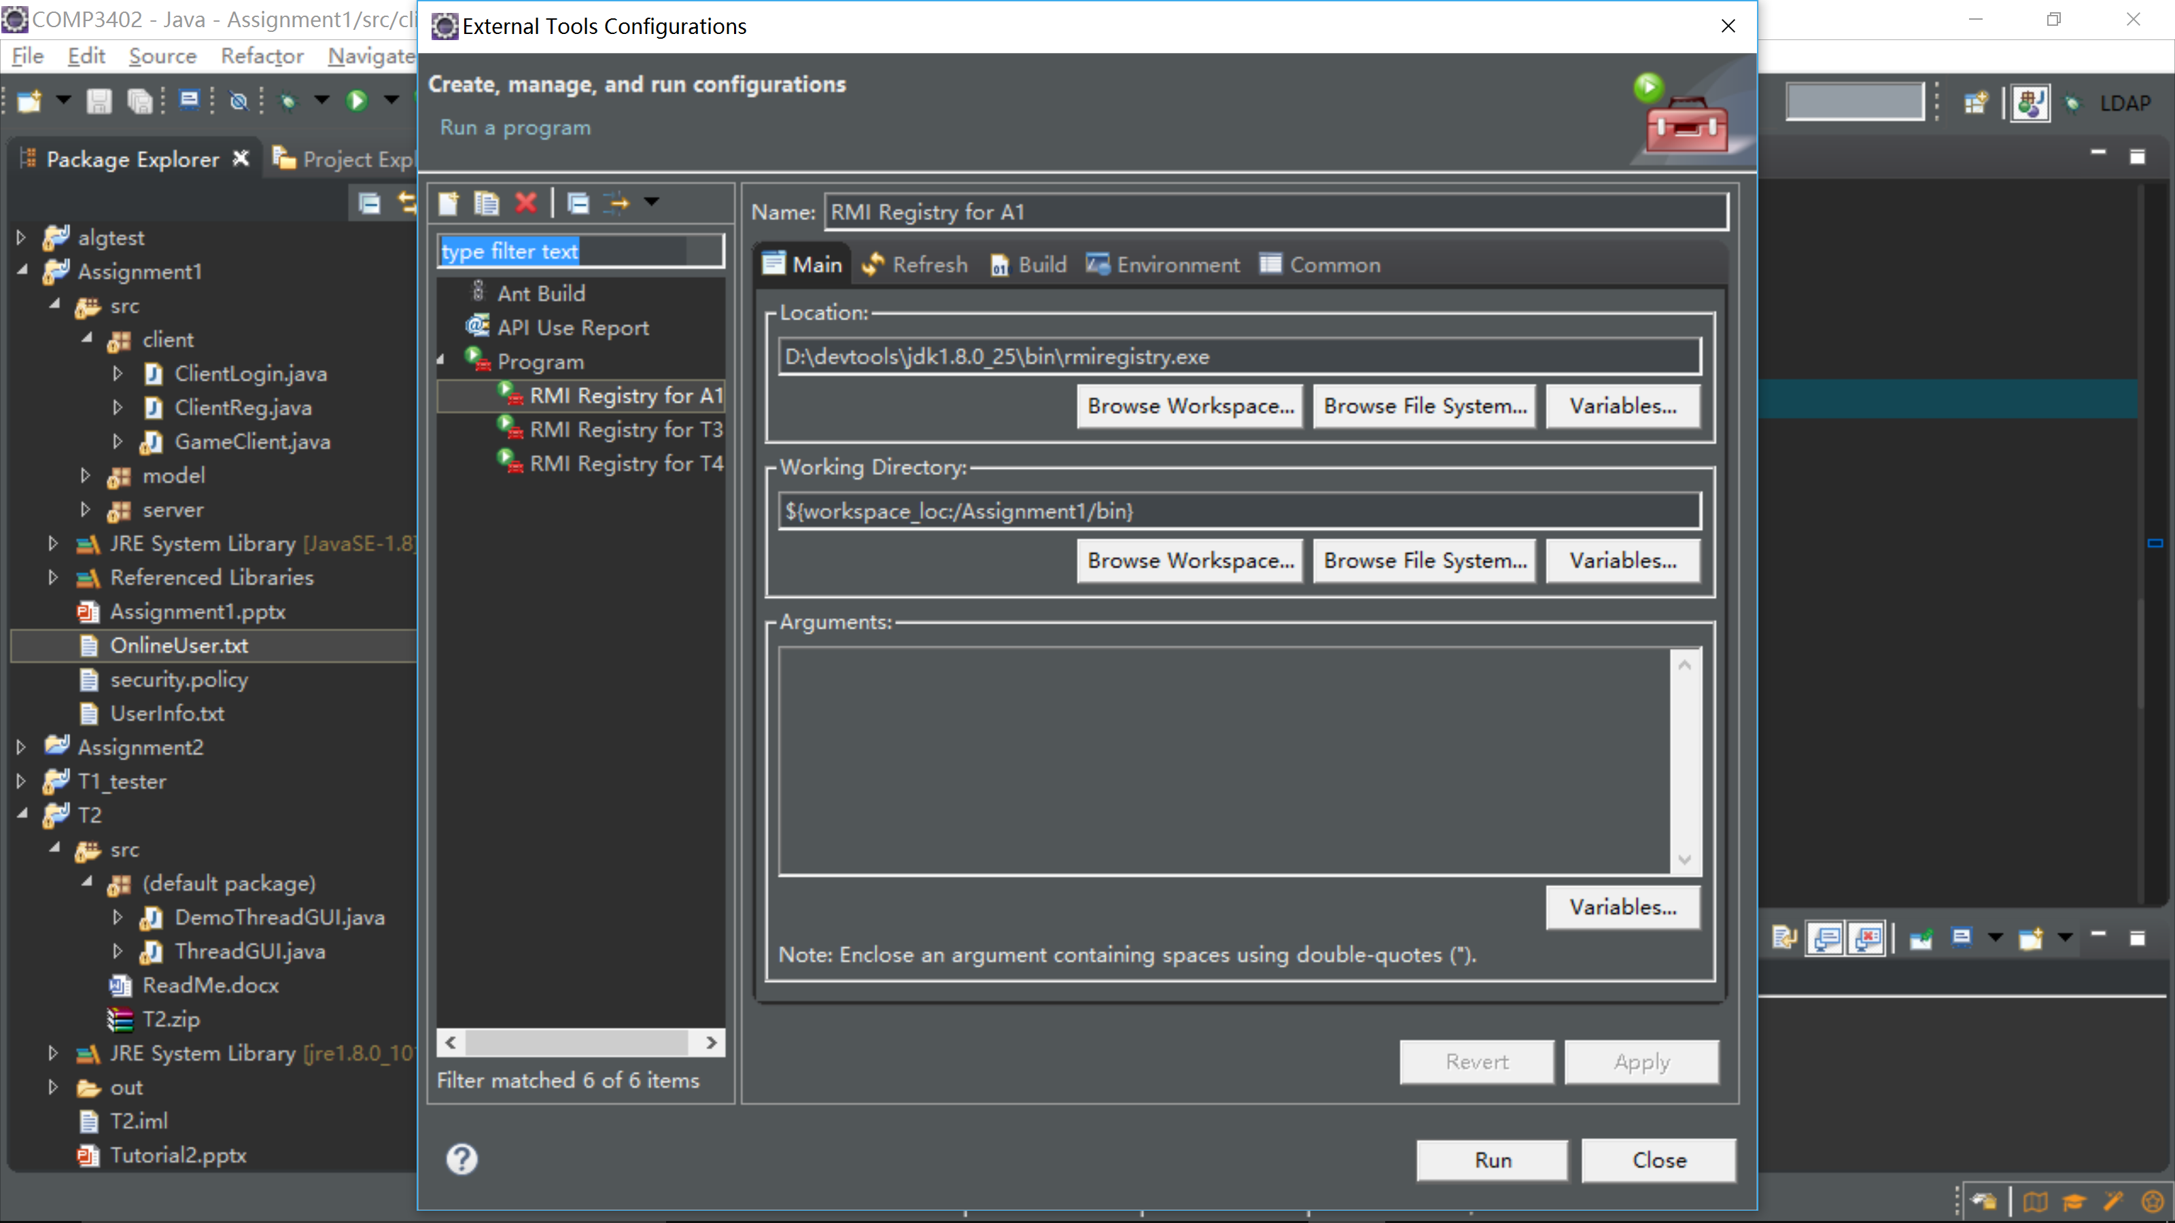

Client Configuration

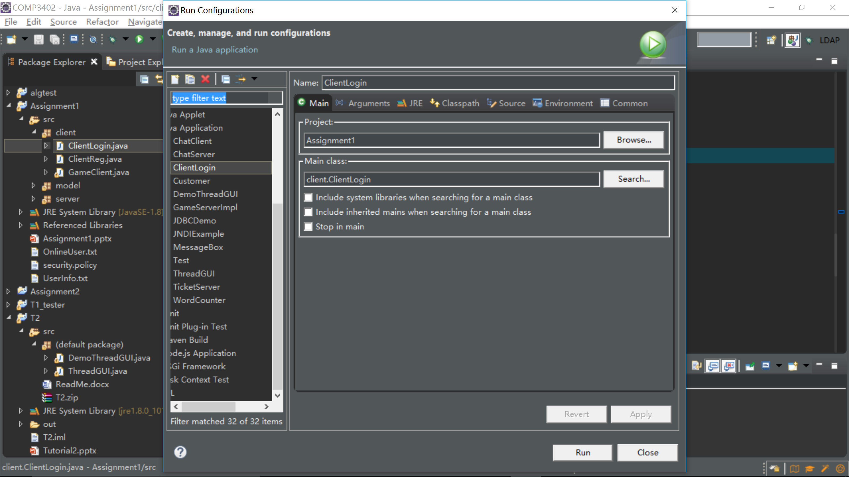

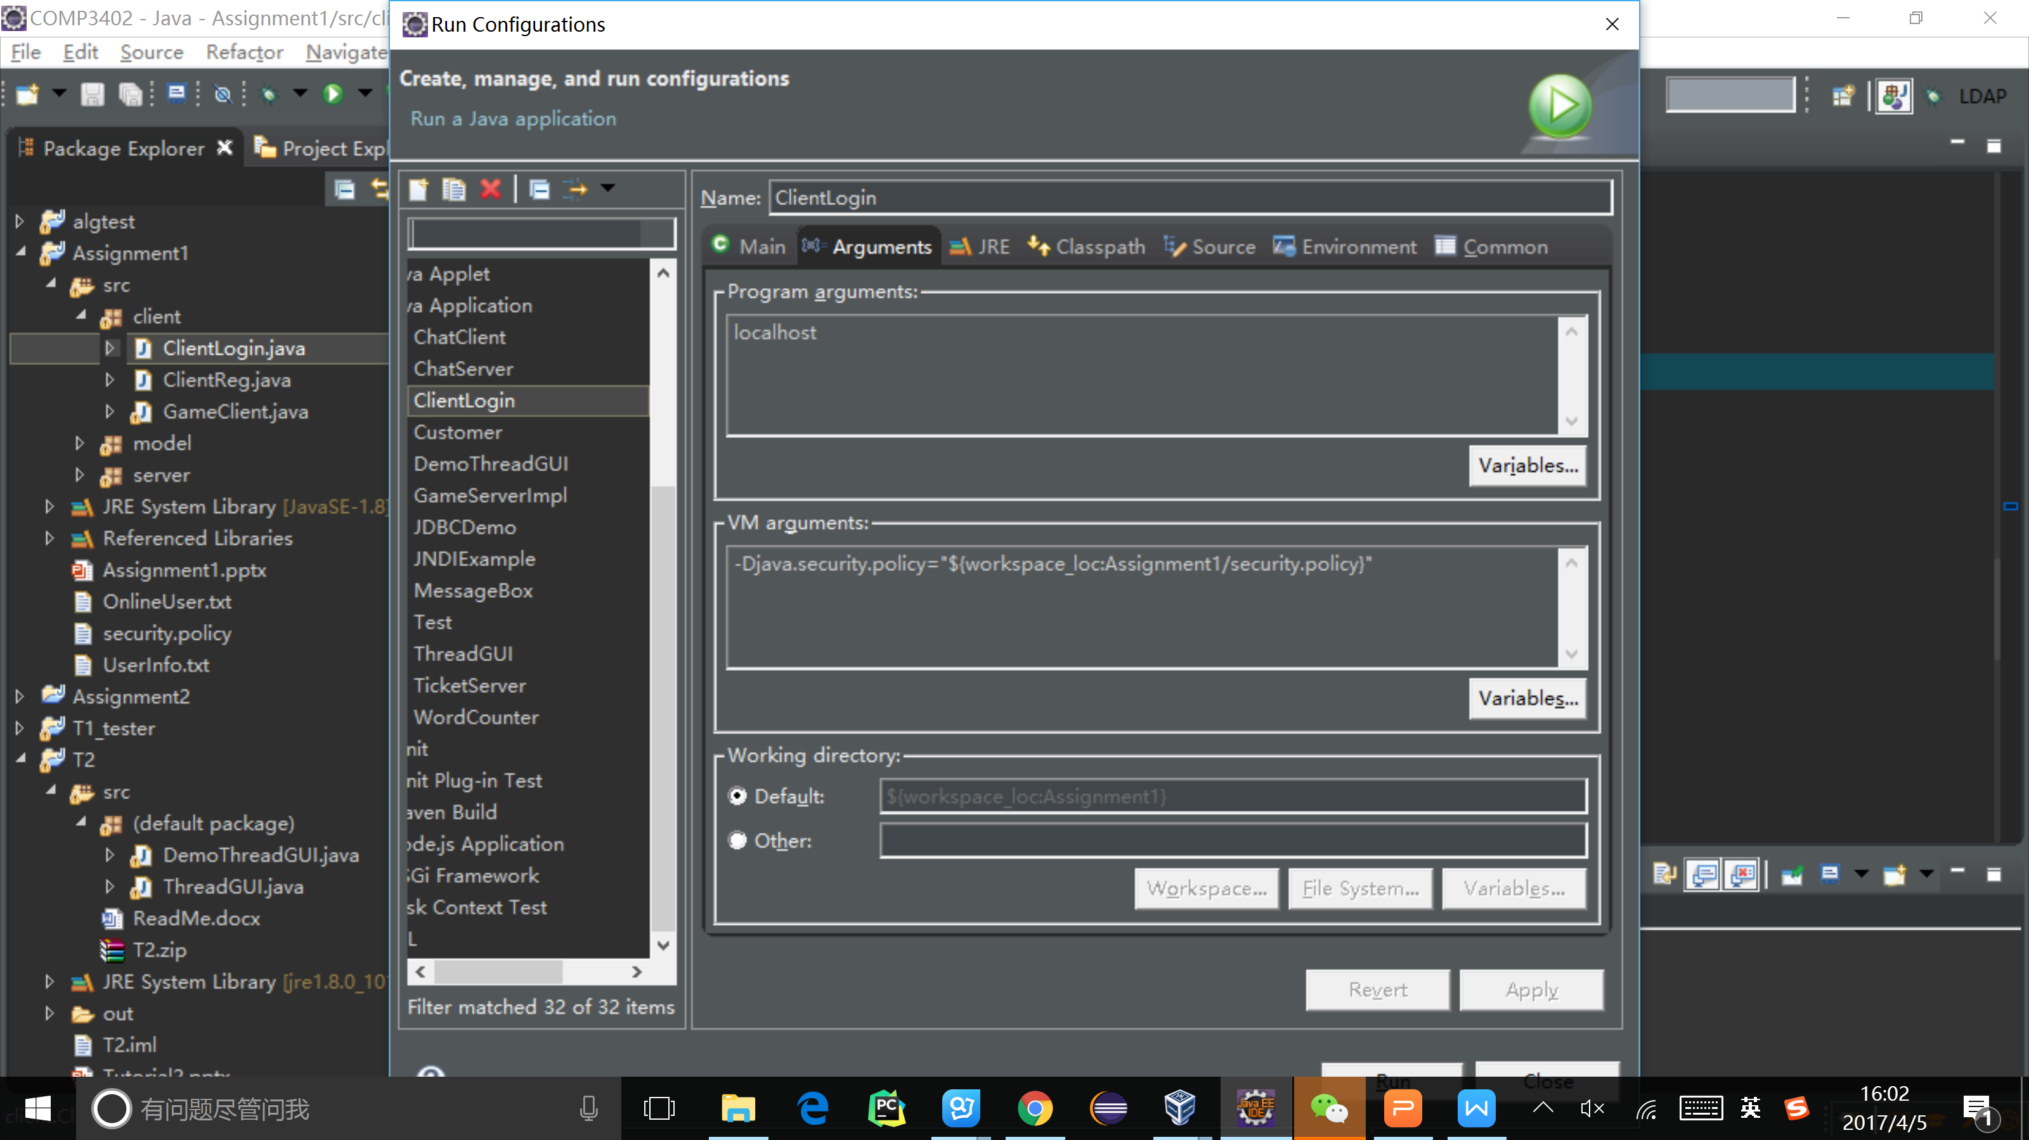

Server Configuration

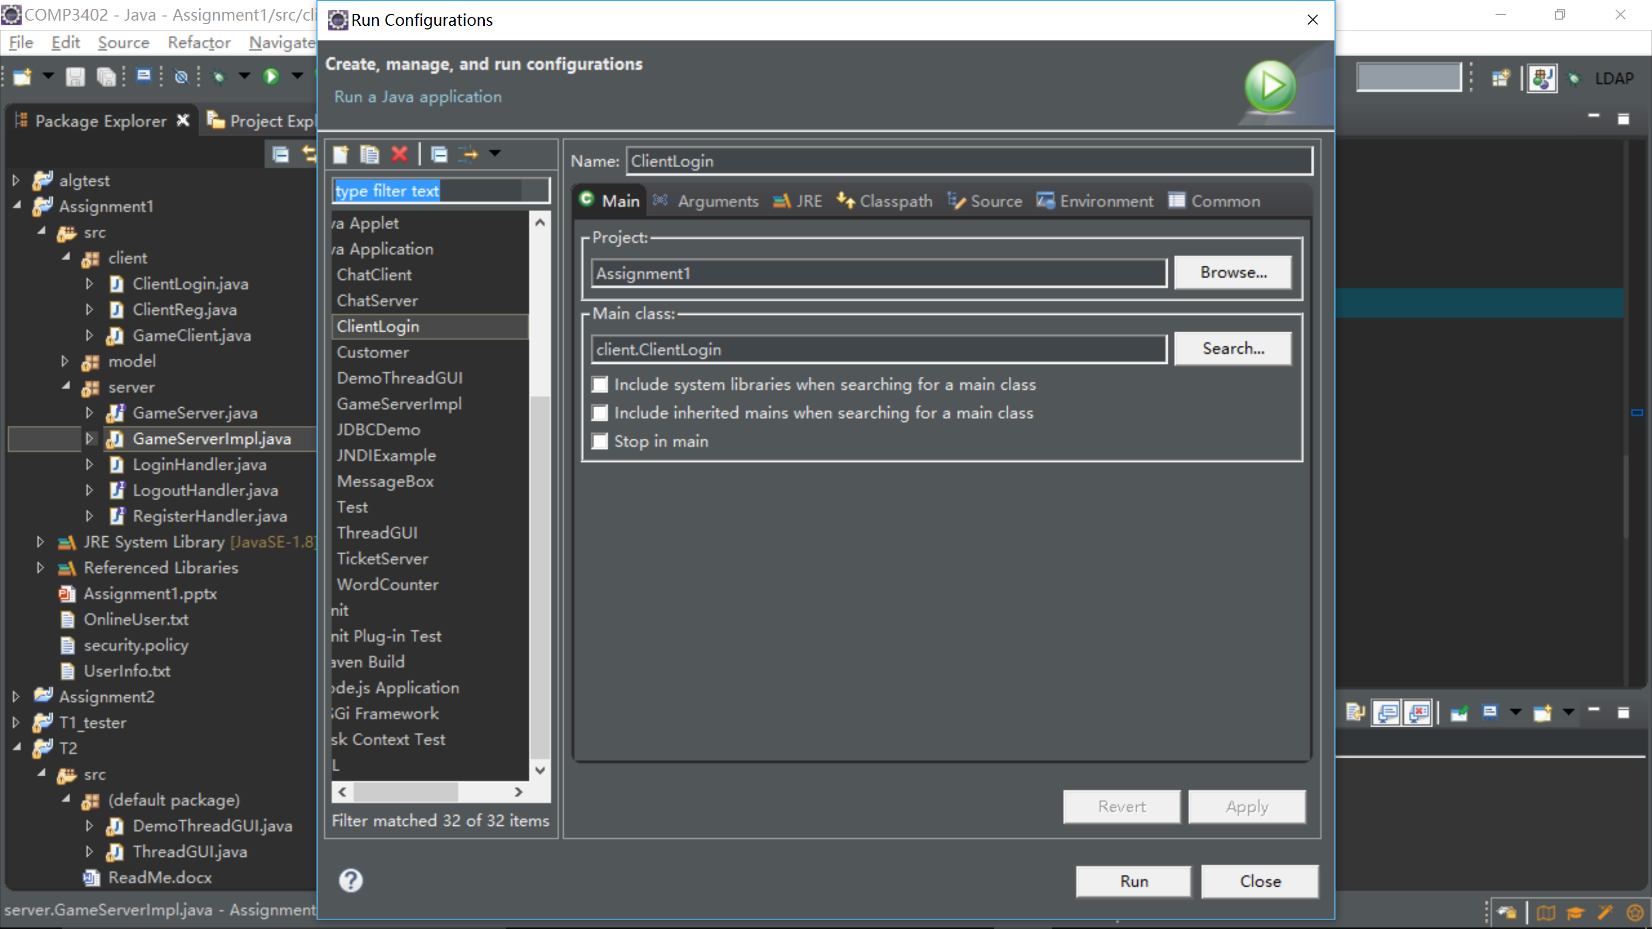

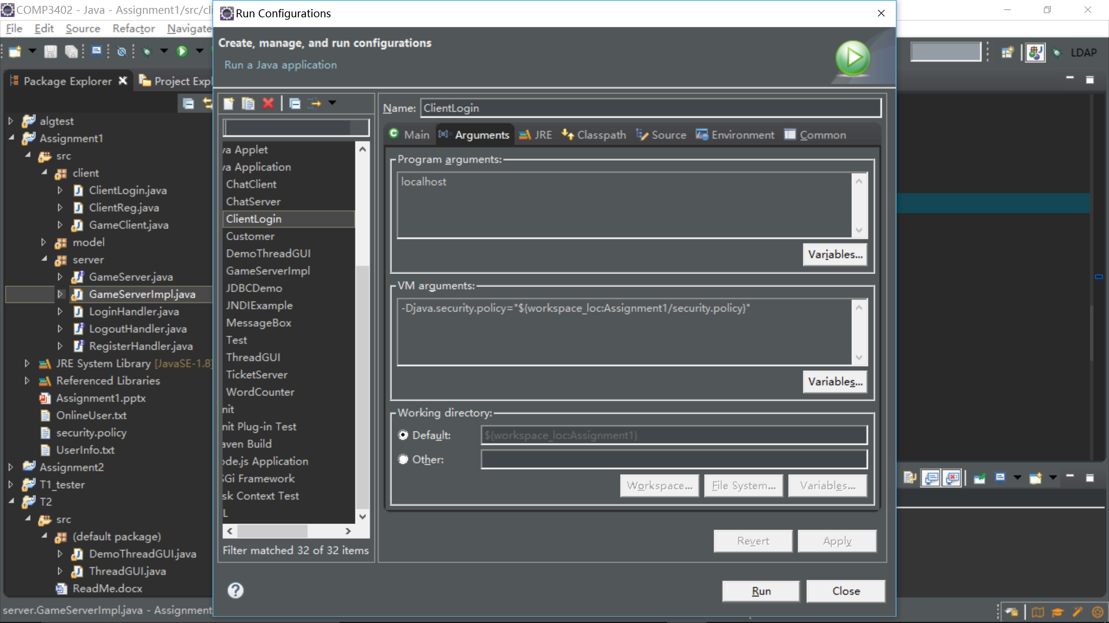

1. Running

2.1 Run RMI configuration for a1

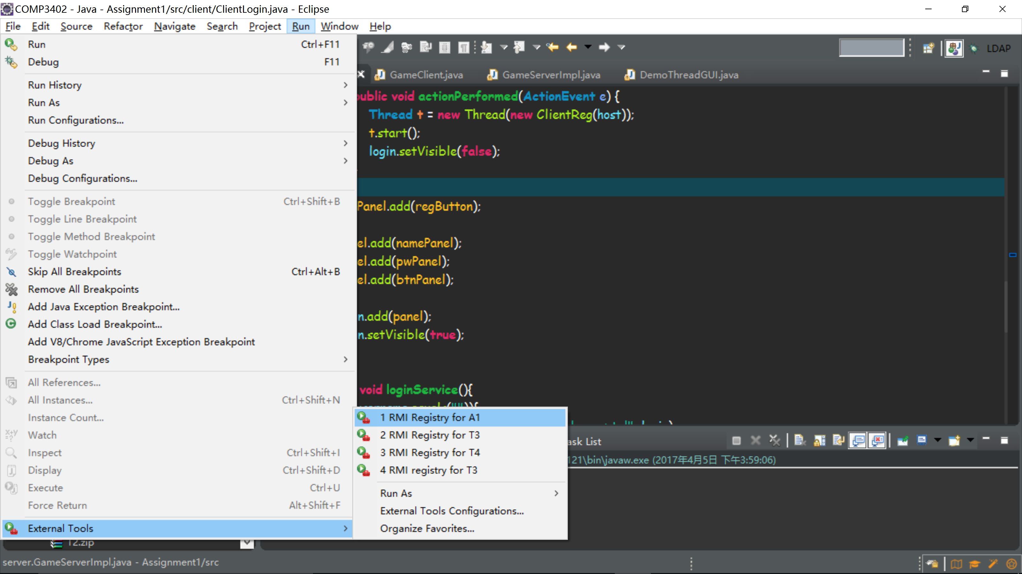

2.2 Run GameServerImpl

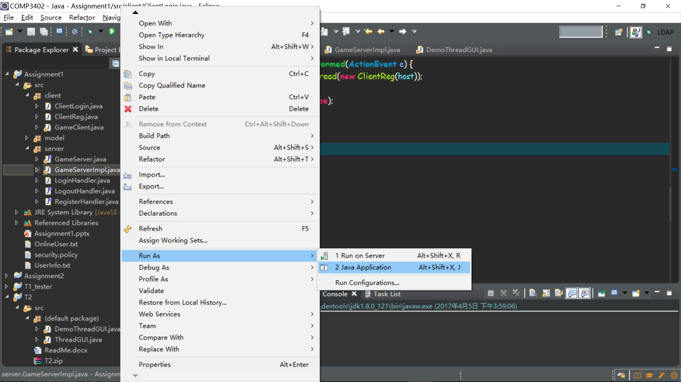

2.3 Run ClientLogin

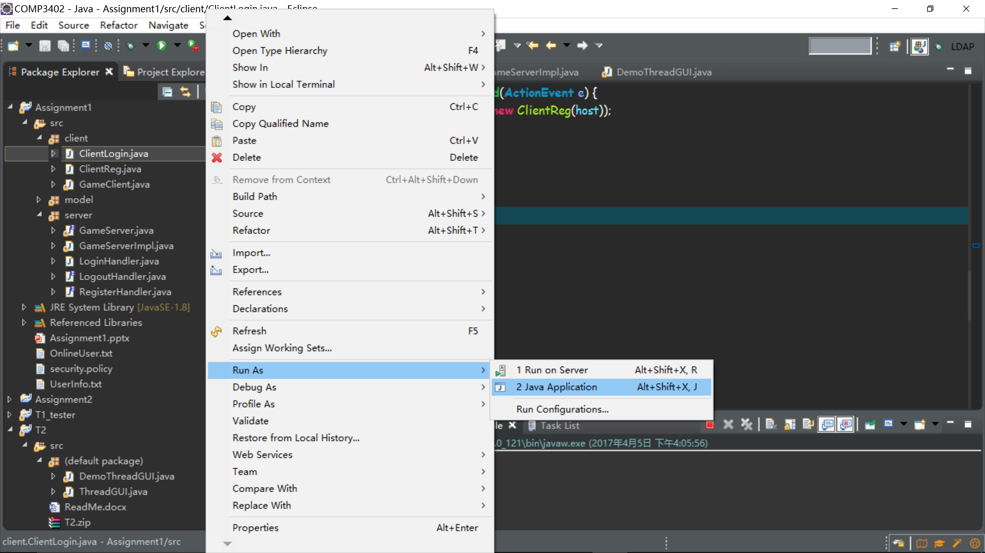

2.4 Support functions

Current user information are recorded in the UserInfo.txt file, please input accordingly a username and password for the test

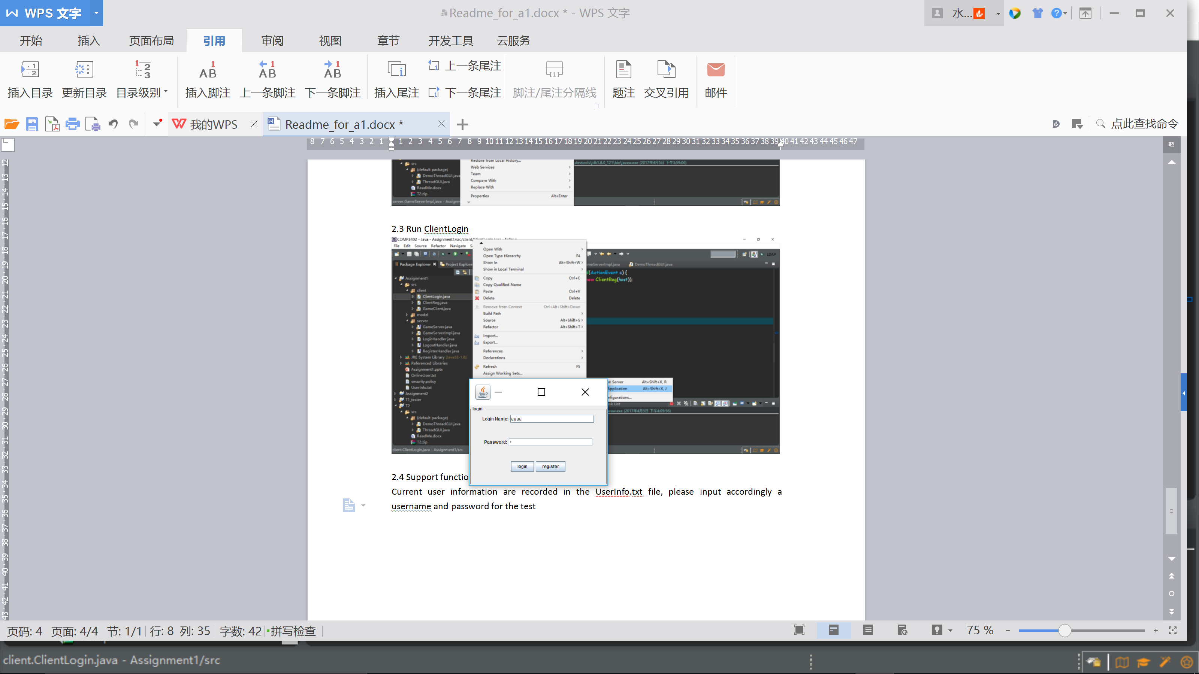

You can also register a new account there, the registry will only success when the password and confirm password are identical, also, the username should be brand new. Here cancel will bring you back to the login window.

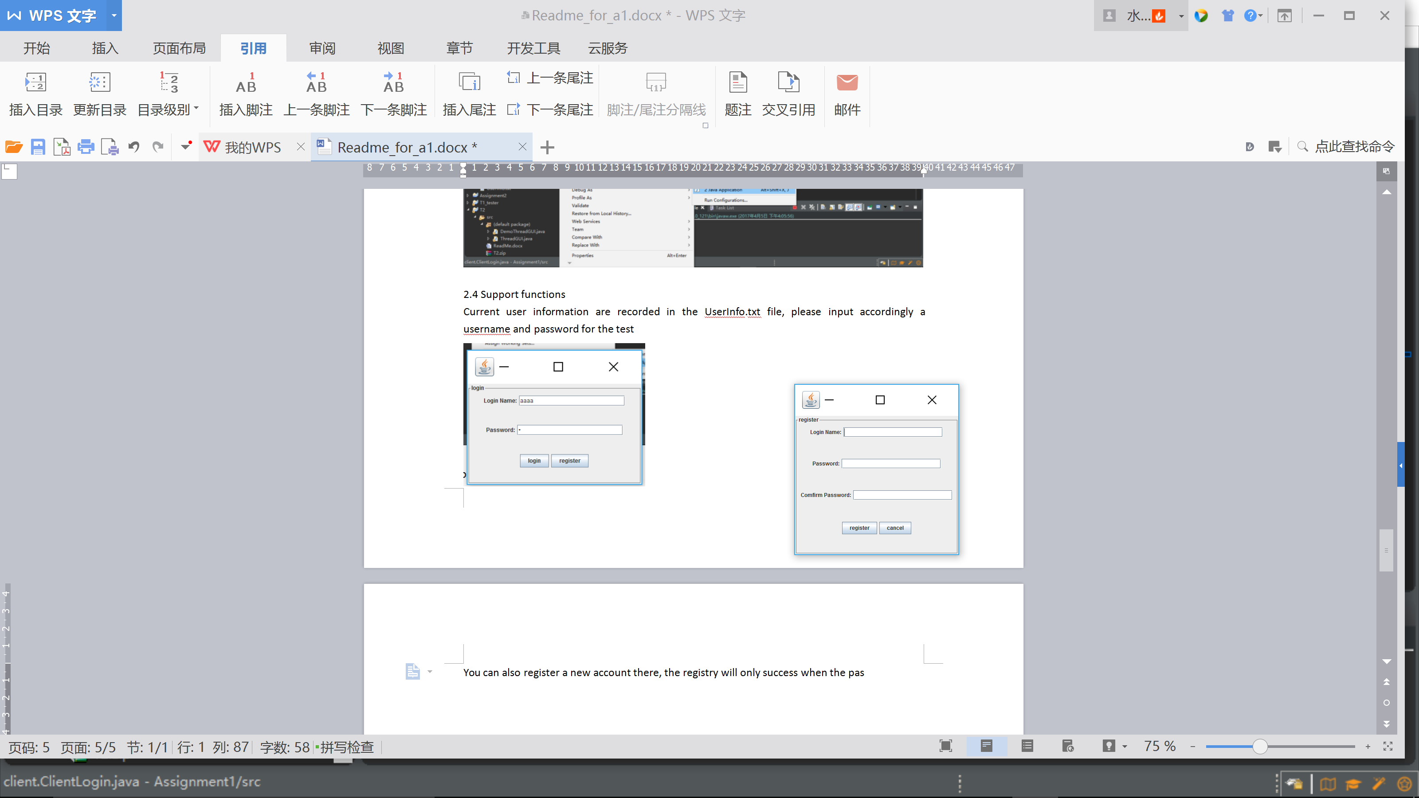

After login, user profile, play game, leader board are three card view. The logout button will handle the logout operation.

